الاسم:عمر محمد محمود حسنين (2)
Chapter 3
1) 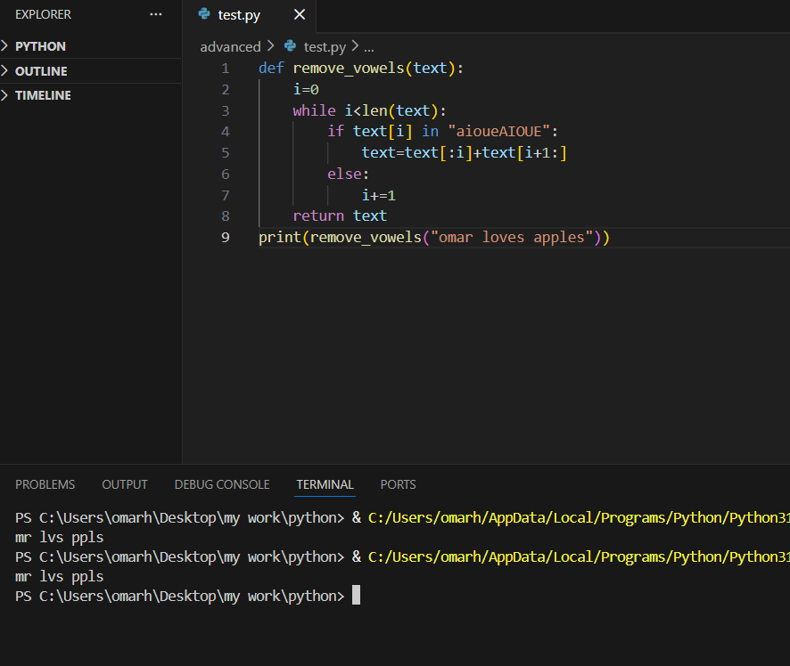
2) 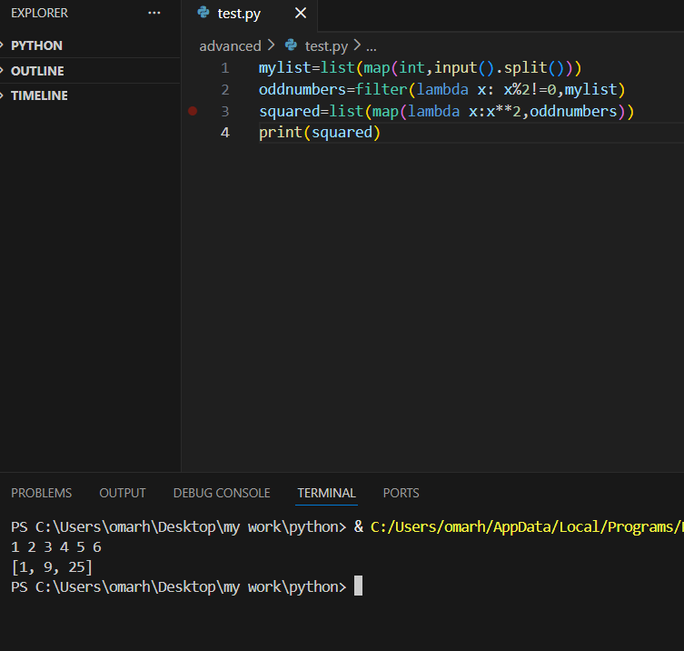
3) 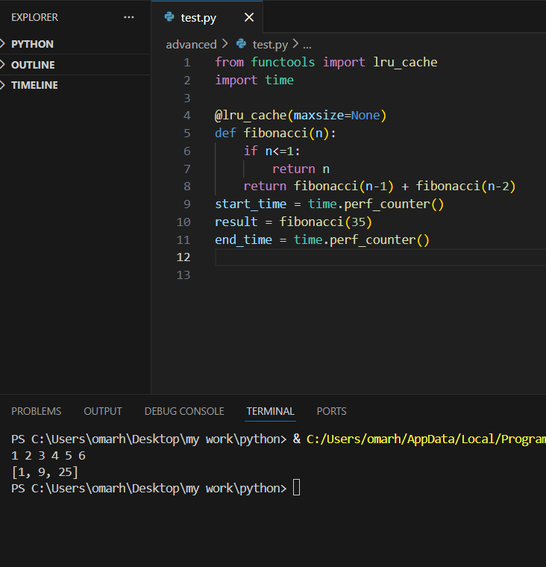
4) 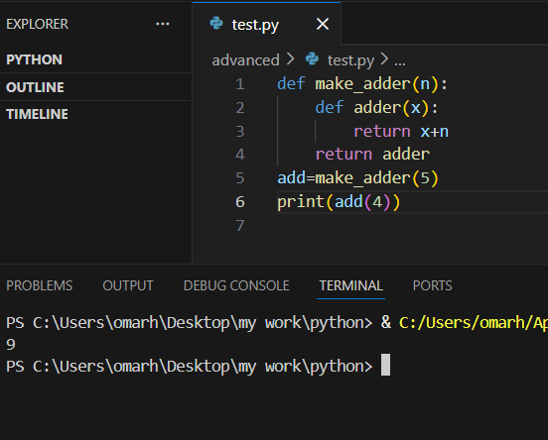

5) 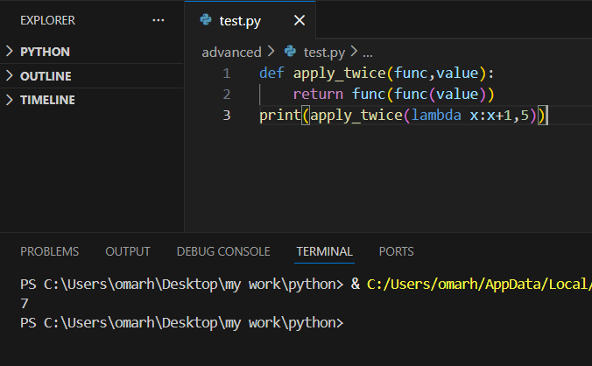

6) 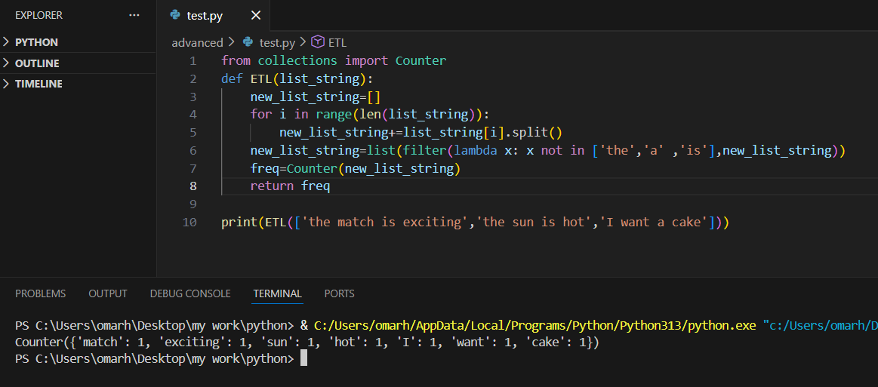

7) I would use reduce function to calculate factorial function
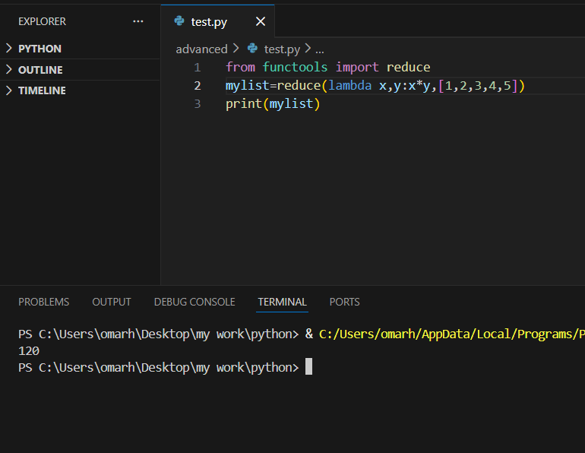
8) 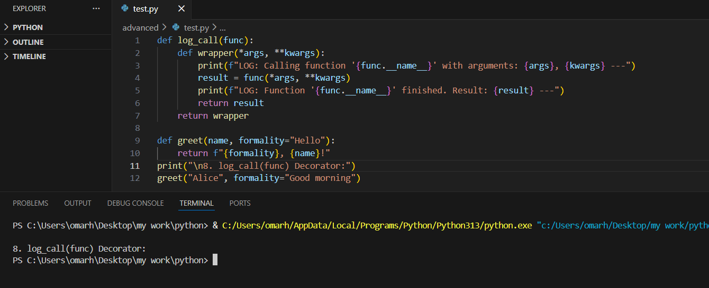
9) Which of the following is a characteristic of a pure function (c)
10) which functional programming concept assures that once a variable is assigned,it cannot be changed (b)
11) which built-in function applies a function to all elements of an iterable and returns an iterator? (c)
12) which module provides the reduce function to python? (c)
13) the filter functionin python returns (b)
14) Functional programming in Python encourages immutability and pure functions (true)
15)The map() function modifies the original iterable in place (false)
16) Closures allow inner functions to access variables from their enclosing function even after the outer function has finished execution (True)
17) The reduce() function is a built-in function in Python and does not require an import (false)
18) itertools provide memory-efficient tools for working with iterators, including infinite sequences (true)

